Lim, Francis Raemark L.

Proofs of testing:

**isWordGuessed function**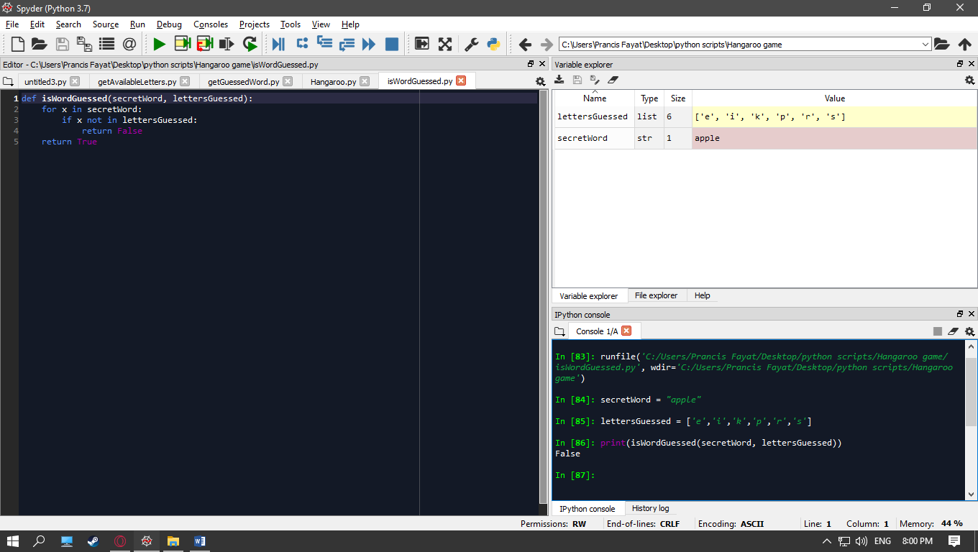

**getAvailableLetters function:**

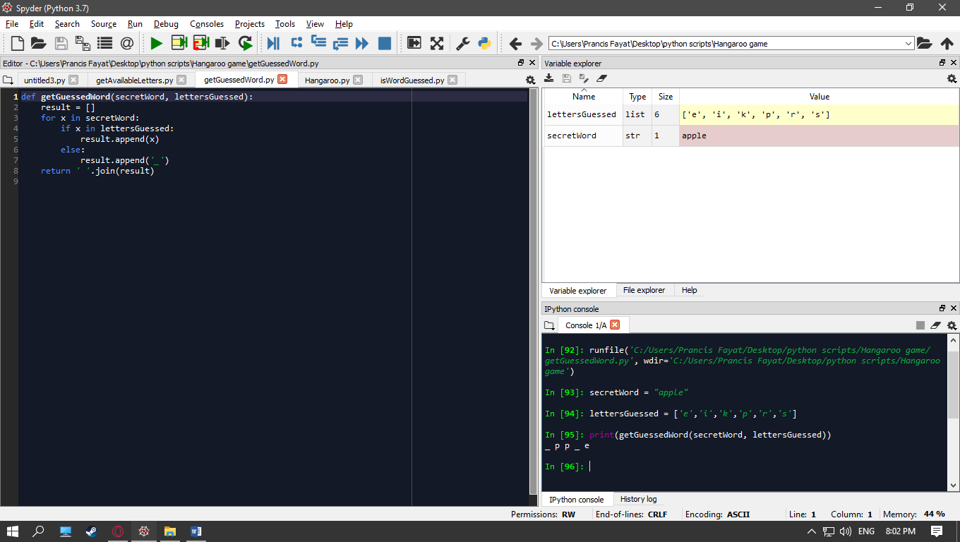

**getAvailableLetters:**

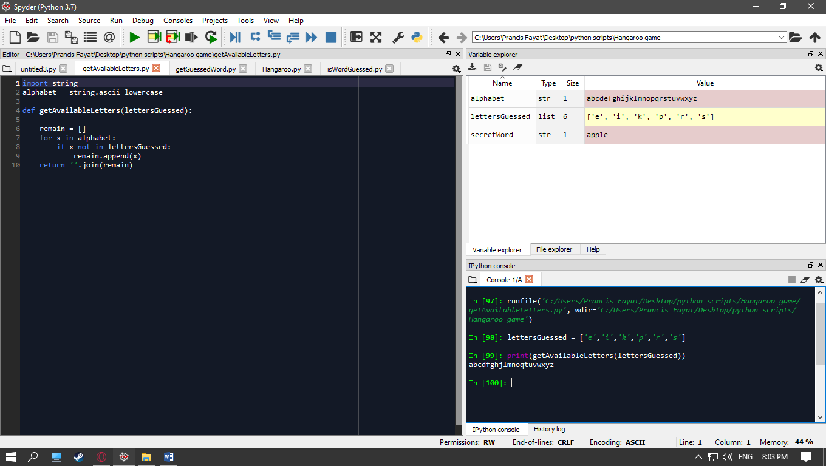

**Hangaroo:**

Scenario 1: inputted letter is not included in the secret word (secretWord), and not in the list of letters guessed (lettersGuessed)

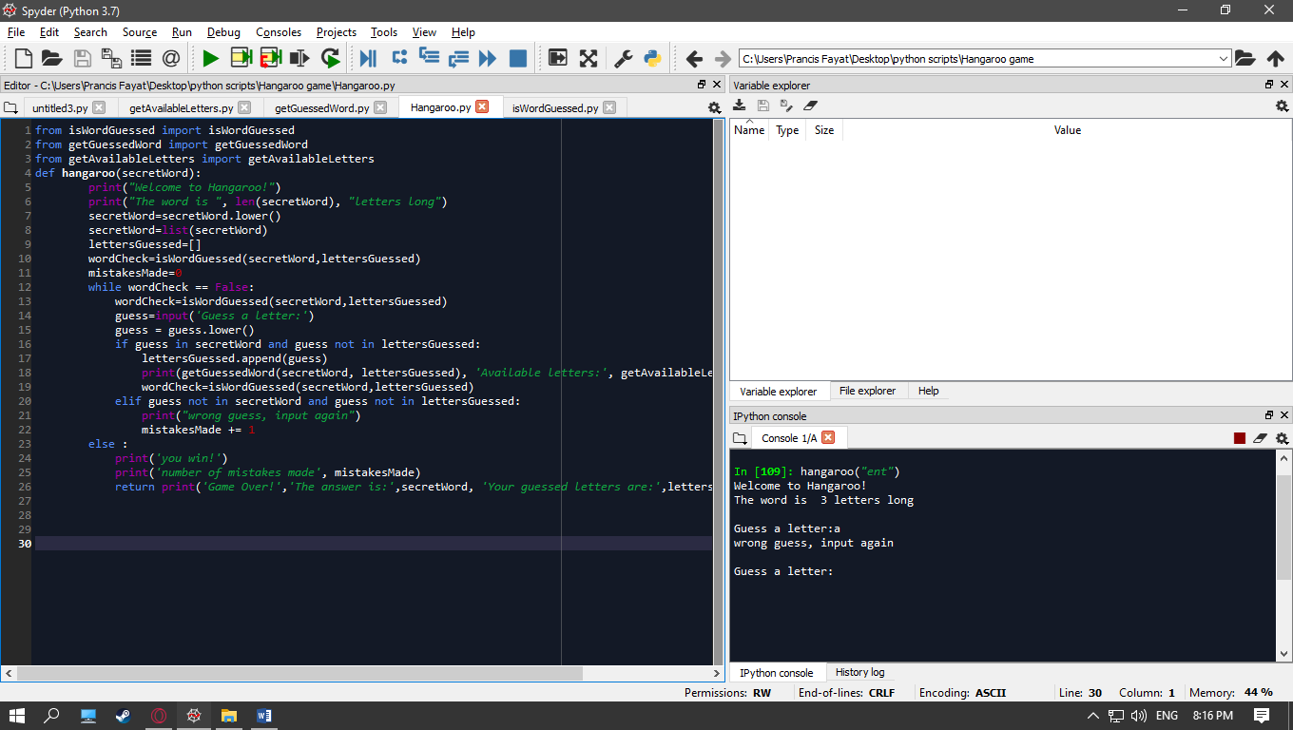

In this code, the game is forgiving such that it does not have a limit on the number of mistakes made. When the input letter is wrong, it gives the user a chance to try again.

Scenario 2: inputted letter is included in the secret word (secretWord), but not in the list of letters guessed (lettersGuessed).

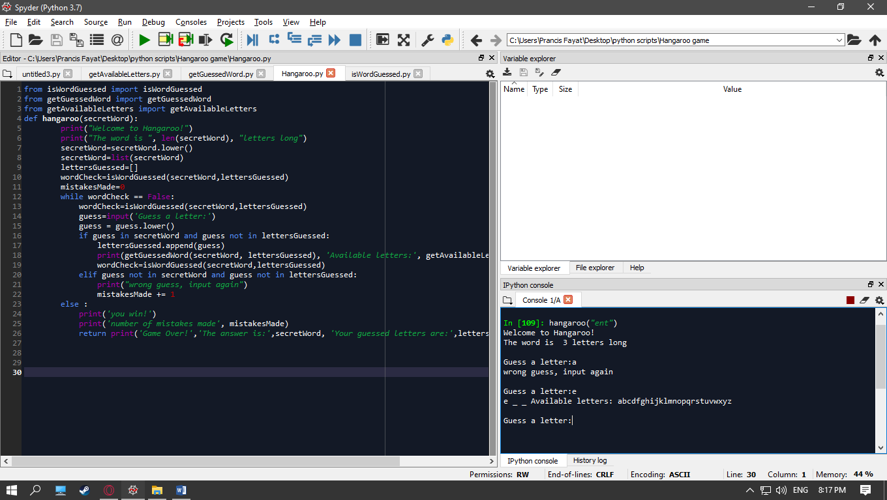

Scenario 3: guessing the correct letters, resulting in a win

